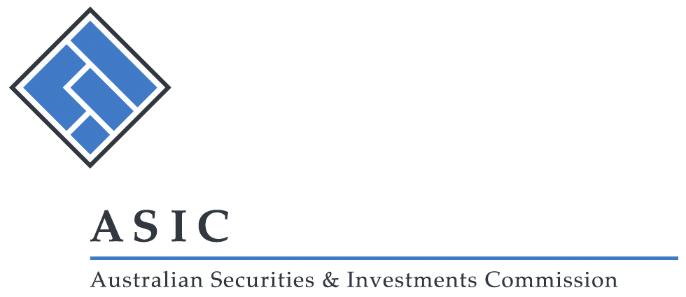

**[PF 195]**

**Pro Forma 195**

**‘Best interest of the members’ expert report**

*Issued: July 2015*

Pro Forma 195 [PF 195] sets out the form in which ASIC will waive the requirement for an independent expert’s report to accompany an explanatory statement in relation to a scheme of arrangement.

Australian Securities and Investments Commission

Corporations Regulations 2001—subregulation 5.1.01(1)

Regulatory Guide 60 Schemes of arrangement [RG 60]

Our Reference: [*Insert reference*]

Your Reference: [*Insert reference*]

[*Insert date*]

[*Insert name of addressee*]

[*Insert position*]

[*Insert address*]

Dear [*name*]

[*Insert name of company*]: **Scheme of Arrangement**

**‘Best interest of the members’ expert report**

Under subregulation 5.1.01(1) of the Corporations Regulations 2001 (Corporations Regulations) the Australian Securities and Investments Commission (ASIC) allows [*insert name of company*] to send an explanatory statement in relation to the proposed scheme of arrangement, which does not contain or have annexed to it a copy of a report referred to in clause 8303 of Part 3 of Schedule 8 of the Corporations Regulations.

ASIC allows this on the basis that the explanatory statement sent is substantially in the form which was given to ASIC on or about [*insert date*].

Yours faithfully

as a delegate of the Australian Securities and Investments Commission